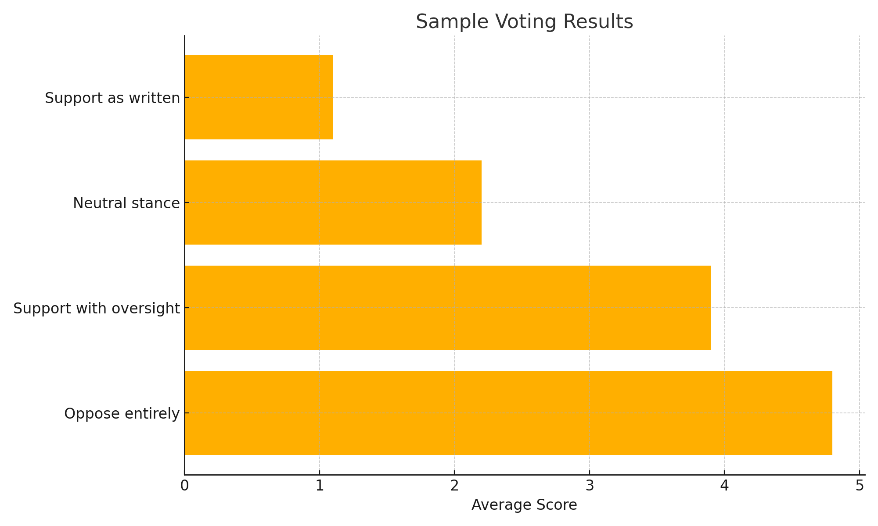
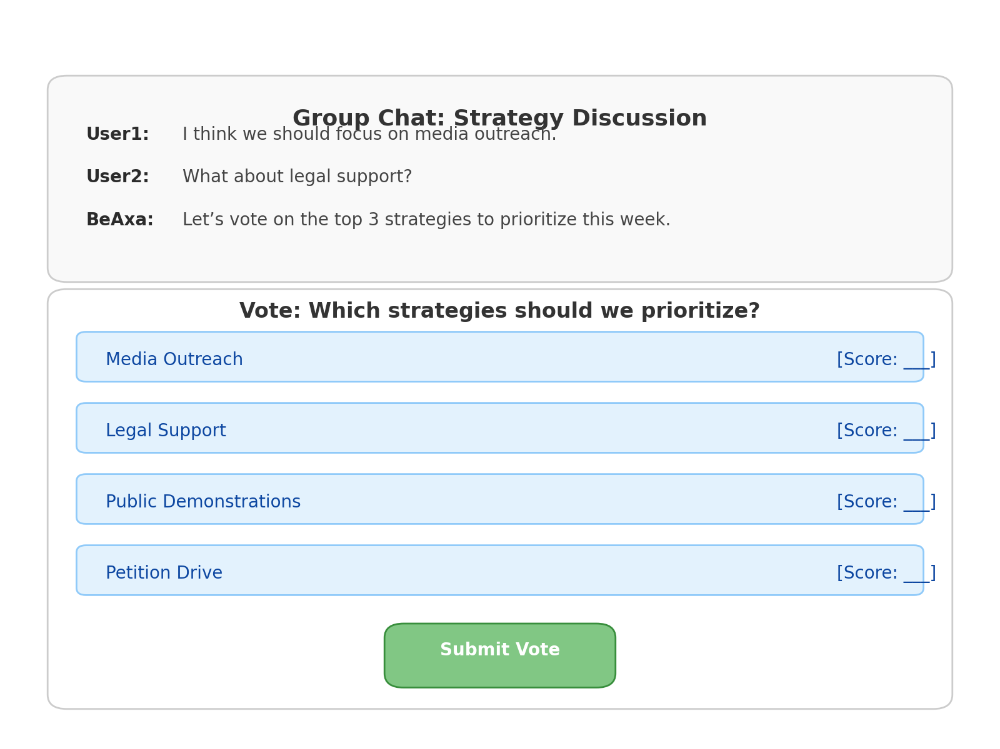
Designing a Flexible, Intuitive Voting

Abstract
This paper presents a proposed voting system for Groupbuild, a platform designed to coordinate group efforts and discussions across a range of contexts, including leadership decisions, policy formation, civil strategy, and global cooperation. The system prioritizes ease of use, transparency, and adaptability for both human users and AI facilitators. Initially targeted at a U.S. audience, it is designed for scalability to a global user base. This document outlines the rationale behind the chosen voting method, details the user interface integration for web-based use, and presents visual mockups demonstrating how users will interact with the system.

1. Introduction
Groupbuild is envisioned as a participatory platform where users collaborate on shared projects, deliberate on strategies, and co-create social or technological solutions. At its core, Groupbuild requires a voting mechanism that can support diverse decision-making contexts without overcomplicating the user experience. The system must also accommodate input from advanced AIs (such as BeAxa) and enable persistent consensus tracking over time.

2. Design Criteria
To meet the needs of Groupbuild's mission, the voting system must:
- Be easy to understand and intuitive for first-time users.
- Support both quick polls and deep deliberation processes.
- Allow for weighted voting and ranked choice where relevant.
- Be modular and API-accessible for AI and backend extensions.
- Work well on mobile and desktop.
- Be culturally adaptable for international rollout.

3. Chosen System: Score Voting (with Ranked-Choice Extensions)
Score Voting (also known as range voting) allows voters to assign a score (e.g., 0–5) to each option. This method is transparent, easily understandable, and reflects intensity of preference. It supports:
- Binary issues (Yes/No or For/Against)
- Multi-option scenarios (e.g., 5 policy suggestions)
- AI-generated options with human override
To enable nuanced decision-making, especially in leadership or strategy discussions, Ranked Choice Voting can be added as an optional mode, triggered by the context or user preference.

4. Implementation in Groupbuild Website
The voting module will be embedded into Groupbuild's discussion and decision threads. It will have the following key components:
- Poll Setup Interface (for organizers or AIs)
- Voter Interface (for participants)
- Results Dashboard (real-time and final)

5. Mockups and Interface Features
Below is an example of how the results dashboard might appear to users, showing scores for various options.

6. Voting UI within Group Chat Context
The following graphic demonstrates an improved version of the voting interface embedded within a group chat, styled to match modern web app design conventions and aligned with Groupbuild's latest site aesthetic. Each chat is clearly delineated, and voting options are easily scannable, cleanly formatted, and interactively aligned for mobile or desktop use.

